SET SOURCES

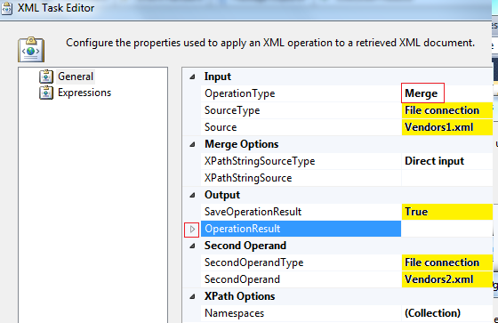

OUTPUT TO MERGE

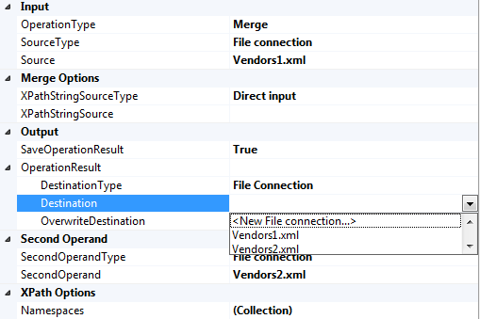

SET A NEW FILE

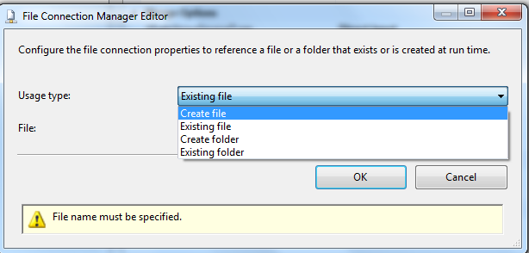

CLICK BROWSE

LOOK FOR THE FOLDER AND TYPE THE NEW NAME, THEN CLICK “OPEN”

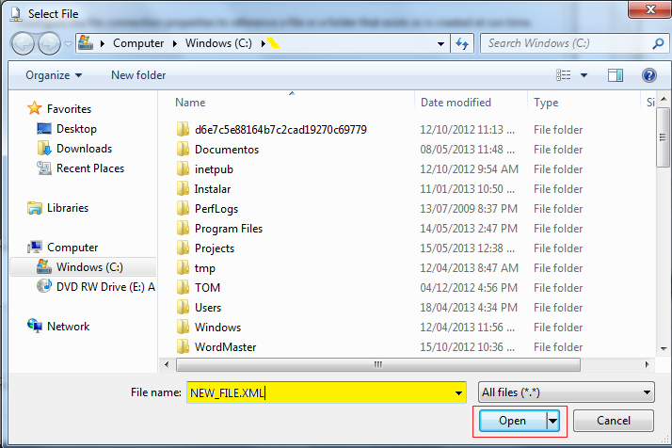

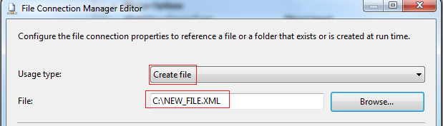

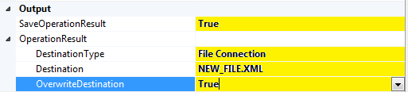

SELECT MERGE OPTIONS, UNDER WHICH NODE TO MERGE

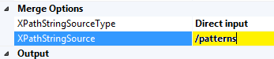

**Bookstore.xml**

<?xml version="1.0"?>

<bookstore specialty="novel">

<book style="autobiography">

<author>

<first-name>Joe</first-name>

<last-name>Bob</last-name>

<award>Trenton Literaty </award>

</author>

<price>55</price>

<book style="textbox">

<author>

<first-name>Mary</first-name>

<last-name>Bob</last-name>

<publication>

<first-name>Mary</first-name>

<last-name>Bob</last-name>

</publication>

</author>

<editor>

<first-name>Britney</first-name>

<last-name>Bob</last-name>

</editor>

<price>55</price>

</book>

</bookstore>

**Merge_xml.xml**

<book style="novel" id="myfave">

<author>

<first-name>Mary</first-name>

<last-name>Bob</last-name>

<publication>Still</publication>

</author>

</book>

**Merged file**

<?xml version="1.0"?>

<bookstore specialty="novel">

<book style="autobiography">

<author>

<first-name>Joe</first-name>

<last-name>Bob</last-name>

</author>

<price>55</price>

</book>

<book style="textbox">

<author>

<first-name>Mary</first-name>

<last-name>Bob</last-name>

<publication>

<first-name>Mary</first-name>

<last-name>Bob</last-name>

</publication>

</author>

<editor>

<first-name>Britney</first-name>

<last-name>Bob</last-name>

</editor>

<price>55</price>

</book>

<book style="novel" id="myfave">

<author>

<first-name>Mary</first-name>

<last-name>Bob</last-name>

<publication>Still</publication>

</author>

</book>

</bookstore>

Another

**Middle_name.xml**

<middle-name>Ann</middle-name>

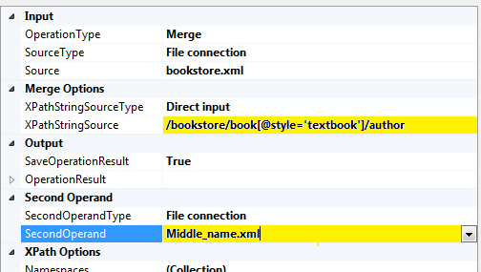

**Output**

<?xml version="1.0"?>

<bookstore specialty="novel">

<book style="autobiography">

<author>

<first-name>Joe</first-name>

<last-name>Bob</last-name>

<award>Trenton Literaty </award>

</author>

<price>55</price>

<book style="**textbox**">

<**author**>

<first-name>Mary</first-name>

<last-name>Bob</last-name>

<publication>

<first-name>Mary</first-name>

<last-name>Bob</last-name>

</publication>

**<middle-name>Ann</middle-name>**

</author>

<editor>

<first-name>Britney</first-name>

<last-name>Bob</last-name>

</editor>

<price>55</price>

</book>

</bookstore>